1. **Using the iris data set implement the KNN algorithm. Take different values for Test and training data set .Also use different values for k. Also find the accuracy level.**

**CODE**

import numpy as np

import matplotlib.pyplot as plt

import pandas as pd

dataset = pd.read_csv("iris.csv")

X = dataset.iloc[:, :-1].values

y = dataset.iloc[:, 4].values

from sklearn.model_selection import train_test_split

X_train, X_test, y_train, y_test = train_test_split(X, y, test_size=0.20)

from sklearn.neighbors import KNeighborsClassifier

classifier = KNeighborsClassifier(n_neighbors=5)

classifier.fit(X_train, y_train)

y_pred = classifier.predict(X_test)

from sklearn.metrics import classification_report, confusion_matrix

print(classification_report(y_test, y_pred))

from sklearn.metrics import accuracy_score

print ("Accuracy : ", accuracy_score(y_test, y_pred))

df = pd.DataFrame({'Real Values':y_test, 'Predicted Values':y_pred})

df

**OUTPUT**

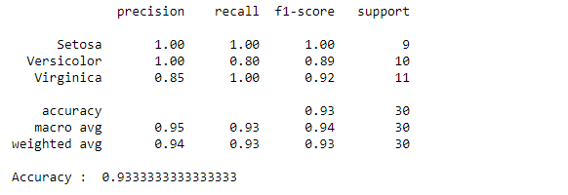

Reference: <https://stackabuse.com/k-nearest-neighbors-algorithm-in-python-and-scikit-learn/>

1. **Download another data set suitable for the KNN and implement the KNN algorithm. Take different values for Test and training data set .Also use different values for k.**

**CODE**

import numpy as np

import matplotlib.pyplot as plt

import pandas as pd

dataset = pd.read_csv("cancer.csv")

dataset.head()

dataset.info()

X = dataset.iloc[:, 2:35].values

print(X)

y = dataset.iloc[:, 1].values

print(y)

from sklearn.model_selection import train_test_split

X_train, X_test, y_train, y_test = train_test_split(X, y, test_size=0.20)

from sklearn.neighbors import KNeighborsClassifier

classifier = KNeighborsClassifier(n_neighbors=5)

classifier.fit(X_train, y_train)

y_pred = classifier.predict(X_test)

from sklearn.metrics import classification_report, confusion_matrix

print(classification_report(y_test, y_pred))

from sklearn.metrics import accuracy_score

print ("Accuracy : ", accuracy_score(y_test, y_pred))

df = pd.DataFrame({'Real Values':y_test, 'Predicted Values':y_pred})

df

**OUTPUT**

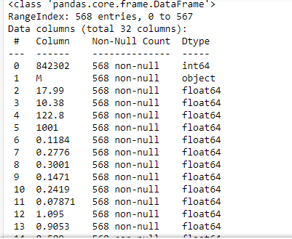

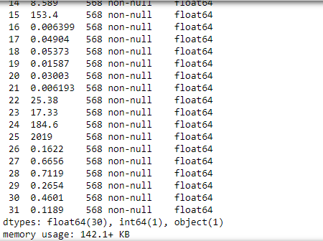

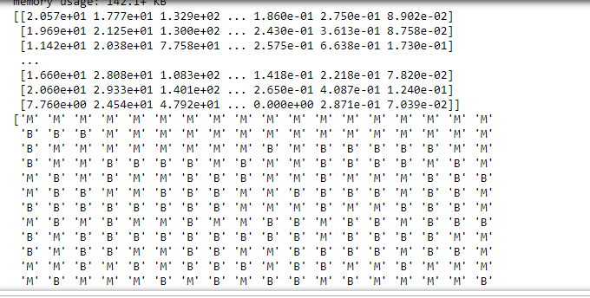

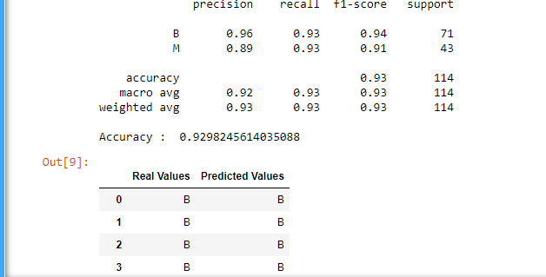

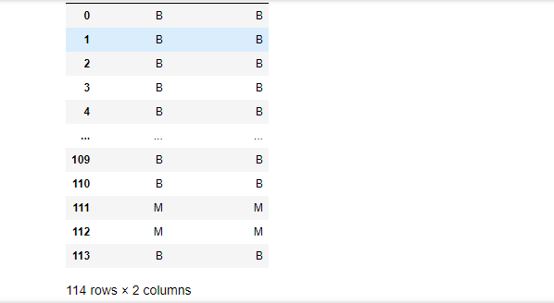

1. **Using iris data set, implement naive bayes classification for different naive Bayes classification algorithms.( (i) gaussian (ii) bernoulli etc)**

* **Find out the accuracy level w.r.t to each  algorithm**
* **Display the no:of mislabeled classification from test data set**
* **List out the class labels of the mismatching records**

**i)CODE**

import numpy as np

import matplotlib.pyplot as plt

import pandas as pd

dataset = pd.read_csv('iris.csv')

X = dataset.iloc[:,:4].values

y = dataset['variety'].values

dataset.head(5)

from sklearn.model_selection import train_test_split

X_train, X_test, y_train, y_test = train_test_split(X, y, test_size = 0.2)

from sklearn.naive_bayes import GaussianNB

classifier = GaussianNB()

classifier.fit(X_train, y_train)

y_pred = classifier.predict(X_test)

y_pred

from sklearn.metrics import confusion_matrix

cm = confusion_matrix(y_test, y_pred)

from sklearn.metrics import accuracy_score

print ("Accuracy : ", accuracy_score(y_test, y_pred))

cm

df = pd.DataFrame({'Real Values':y_test, 'Predicted Values':y_pred})

df

**OUTPUT**

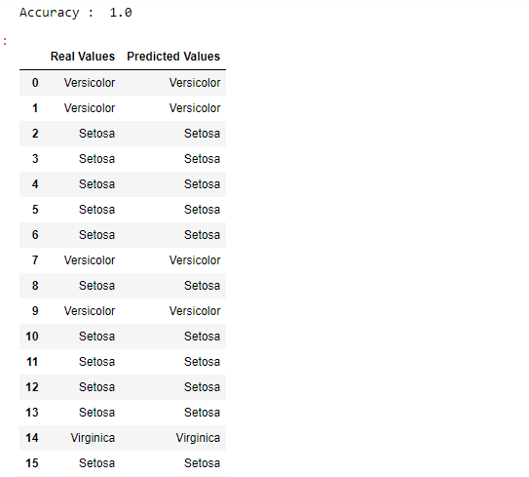

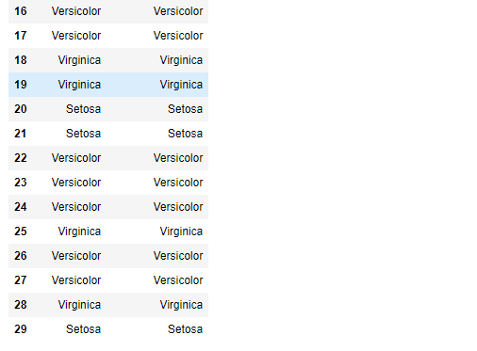

**CODE**

import numpy as np

import matplotlib.pyplot as plt

import pandas as pd

dataset = pd.read_csv('iris.csv')

X = dataset.iloc[:,:4].values

y = dataset['variety'].values

dataset.head(5)

from sklearn.model_selection import train_test_split

X_train, X_test, y_train, y_test = train_test_split(X, y, test_size = 0.2)

from sklearn.naive_bayes import BernoulliNB

classifier = BernoulliNB()

classifier.fit(X_train, y_train)

y_pred = classifier.predict(X_test)

y_pred

from sklearn.metrics import confusion_matrix

cm = confusion_matrix(y_test, y_pred)

from sklearn.metrics import accuracy_score

print ("Accuracy : ", accuracy_score(y_test, y_pred))

cm

# df = pd.DataFrame({'Real Values':y_test, 'Predicted Values':y_pred})

# df

**OUTPUT**

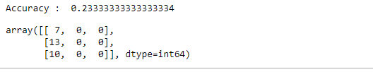

**ii)CODE**

import numpy as np

import matplotlib.pyplot as plt

import pandas as pd

dataset = pd.read_csv('iris.csv')

X = dataset.iloc[:,:4].values

y = dataset['variety'].values

dataset.head(5)

from sklearn.model_selection import train_test_split

X_train, X_test, y_train, y_test = train_test_split(X, y, test_size = 0.2)

from sklearn.naive_bayes import BernoulliNB

classifier = BernoulliNB()

classifier.fit(X_train, y_train)

y_pred = classifier.predict(X_test)

y_pred

#from sklearn.metrics import confusion_matrix

#cm = confusion_matrix(y_test, y_pred)

from sklearn.metrics import accuracy_score

print ("Accuracy : ", accuracy_score(y_test, y_pred))

#cm

df = pd.DataFrame({'Real Values':y_test, 'Predicted Values':y_pred})

df

**OUTPUT**

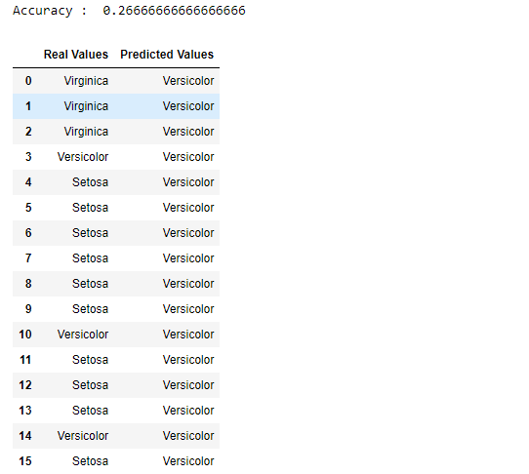

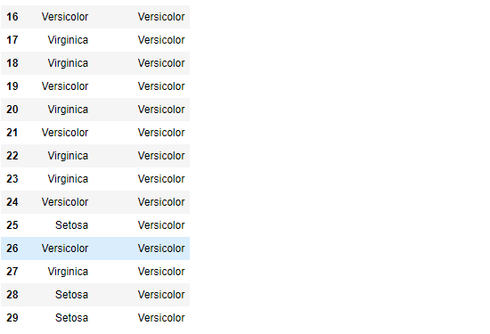

References:

<https://towardsdatascience.com/machine-learning-basics-naive-bayes-classification-964af6f2a965>

<https://scikit-learn.org/stable/modules/classes.html#module-sklearn.naive_bayes>

1. Use car details CSV file and implement decision tree algorithm

* Find out the accuracy level.
* Display the no:of mislabeled classification from test data set
* List out the class labels of the mismatching records

CODE

import os

import numpy as np

import pandas as pd

import numpy as np, pandas as pd

import matplotlib.pyplot as plt

from sklearn import tree, metrics, model_selection

data = pd.read_csv('car.csv',names=['buying','maint','doors','persons','lug_boot','safety','class'])

data.head()

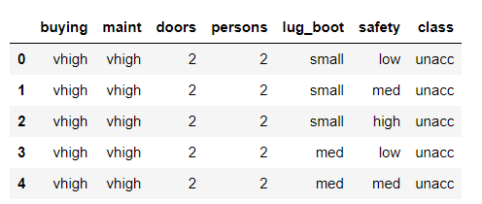

data.info()

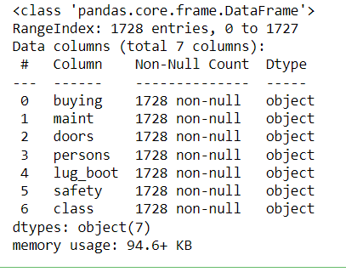

data['class'],class_names = pd.factorize(data['class'])

print(class_names)

print(data['class'].unique())

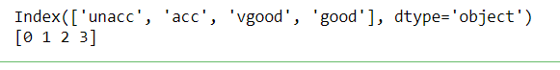

data['buying'],_ = pd.factorize(data['buying'])

data['maint'],_ = pd.factorize(data['maint'])

data['doors'],_ = pd.factorize(data['doors'])

data['persons'],_ = pd.factorize(data['persons'])

data['lug_boot'],_ = pd.factorize(data['lug_boot'])

data['safety'],_ = pd.factorize(data['safety'])

data.head()

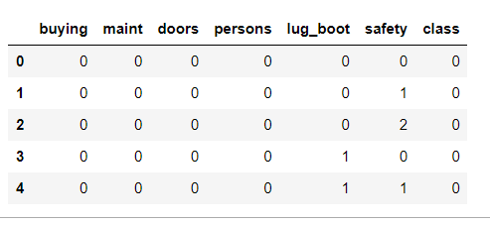

data.info()

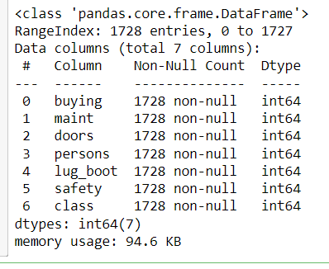

X = data.iloc[:,:-1]

y = data.iloc[:,-1]

# split data randomly into 70% training and 30% test

X_train, X_test, y_train, y_test = model_selection.train_test_split(X, y, test_size=0.3, random_state=0)

# train the decision tree

dtree = tree.DecisionTreeClassifier(criterion='entropy', max_depth=3, random_state=0)

dtree.fit(X_train, y_train)



# use the model to make predictions with the test data

y_pred = dtree.predict(X_test)

# how did our model perform?

accuracy = metrics.accuracy_score(y_test, y_pred)

print('Accuracy: {:.2f}'.format(accuracy))



count_misclassified = (y_test != y_pred).sum()

print('Misclassified samples: {}'.format(count_misclassified))



References:

<https://www.24tutorials.com/machine-learning/case-study-decision-tree-model-for-car-quality/>

<https://notebook.community/bMzi/ML_in_Finance/0210_DecisionTrees>

<https://stackabuse.com/decision-trees-in-python-with-scikit-learn/>

For Data Sets Refer:

<https://www.kaggle.com> ( for data set)

<http://archive.ics.uci.edu/ml/datasets.php>

**5.Implement Simple and multiple linear regression for the data sets ‘student_score.csv’ and ‘company_data .csv’ respectively**

Ref:  <https://stackabuse.com/linear-regression-in-python-with-scikit-learn/>

1. import numpy as np

import pandas as pd

import matplotlib.pyplot as plt

#data set contains details of no.of hours spend by students for studt and their marks

student = pd.read_csv('student_scores.csv')

student.head()

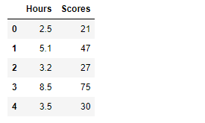

1. student.describe()

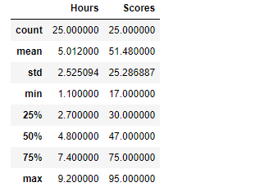

1. student.info()

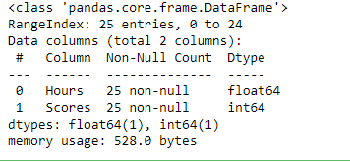

1. import matplotlib.pyplot as plt

Xax=student.iloc[:,0]

Yax=student.iloc[:,1]

plt.scatter(Xax,Yax)

plt.xlabel("No.of hours")

plt.ylabel("Score")

plt.title("Student scores")

plt.show()

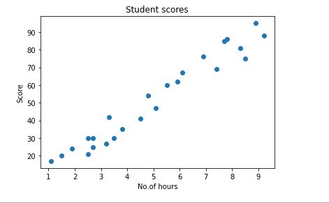

1. #perform the simple linear regression model

#Equation : Y=w0+w1.x

#Here Y(marks)=w0+w1.x

#create x as hours and Y as marks

X = student.iloc[:, :-1]

y = student.iloc[:, 1]

print(X)

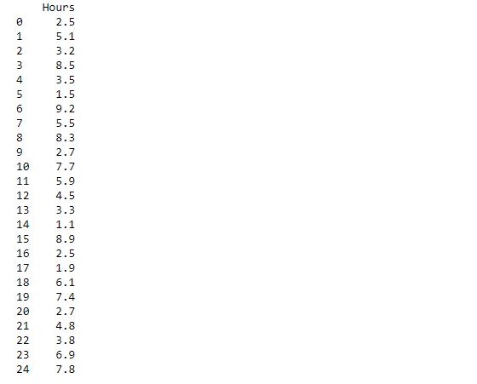

1. print(y)

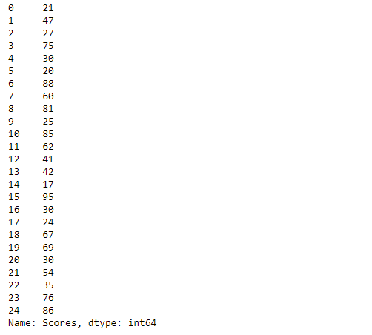

1. from sklearn.model_selection import train_test_split

X_train, X_test, y_train, y_test = train_test_split(X, y, test_size=0.2)

print(X_train)

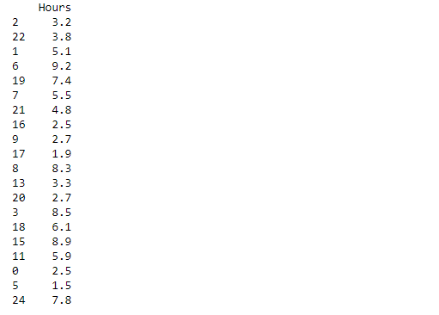

1. from sklearn.linear_model import LinearRegression

regressor = LinearRegression()

regressor.fit(X_train, y_train)



1. print(regressor.intercept_)



1. print(regressor.coef_)



1. y_pred = regressor.predict(X_test)

for(i,j) in zip(y_test,y_pred):

if i!=j:

print("Actual value :",i,"Predicted value :",j)

print("Number of mislabeled points from test data set :", (y_test != y_pred).sum())

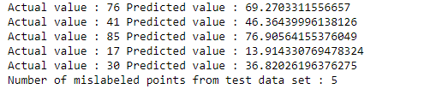

1. from sklearn import metrics

print("Mean Absolute error :", metrics.mean_absolute_error(y_test,y_pred))

print("Mean Squared error :", metrics.mean_squared_error(y_test,y_pred))

print("Root Mean Squared error :", np.sqrt(metrics.mean_squared_error(y_test,y_pred)))

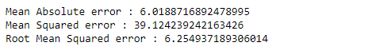

1. import matplotlib.pyplot as plt

c=X_test['Hours'].count()

xax=np.arange(c)

print(xax)

X_axis = np.arange(len(xax))

plt.bar(X_axis-0.2, y_test, 0.6, label='Actual')

plt.bar(X_axis+0.2, y_pred, 0.6, label='Predicted')

plt.xlabel("Test Records")

plt.ylabel("Marks")

plt.title("Student Score prediction")

plt.legend()

plt.show()

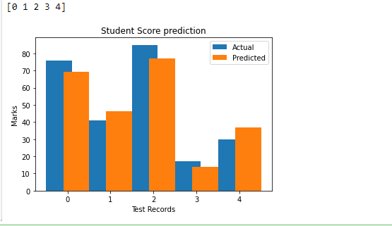

**Multiple Regression**

import pandas as pd

import numpy as np

import matplotlib.pyplot as plt

advertising = pd.read_csv('Company_data.csv')

advertising.head()

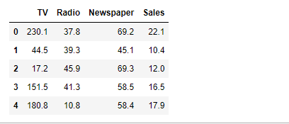

advertising.describe()

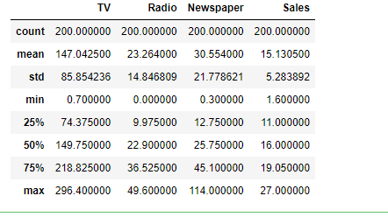

advertising.info()

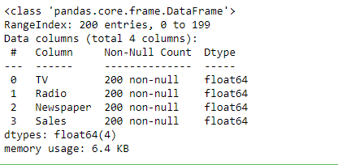

import matplotlib.pyplot as plt

import seaborn as sns

sns.pairplot(advertising, x_vars=['TV', 'Radio', 'Newspaper'],

y_vars='Sales', height=5, aspect=1, kind='scatter')

plt.show()

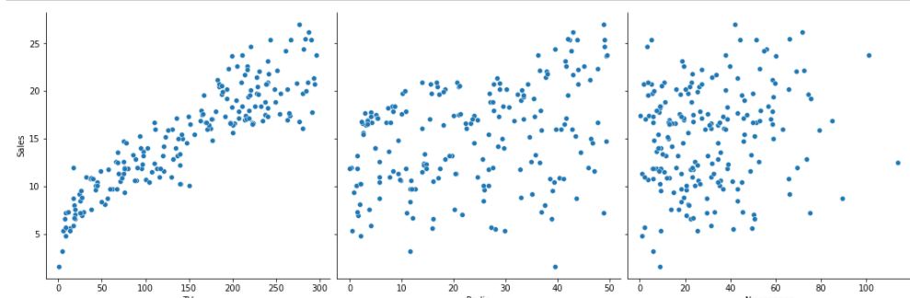

#perform the multiple linear regression model

#Equation : Y=w0+w1.x1 + w2.x2 + w3.x3

#Here Y(sales)=w0+w1.x1(TV)+w2.x2(Radio)+w3.x3(Newspaper)

#create x and Y as sales

X = advertising.iloc[:, :-1]

print(X)

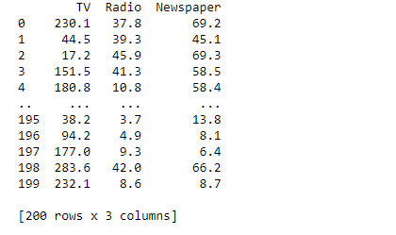

y = advertising.iloc[:, -1]

print(y)

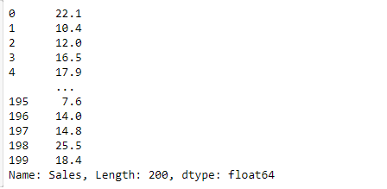

from sklearn.model_selection import train_test_split

X_train, X_test, y_train, y_test = train_test_split(X, y, test_size=0.3)

print(X_train)

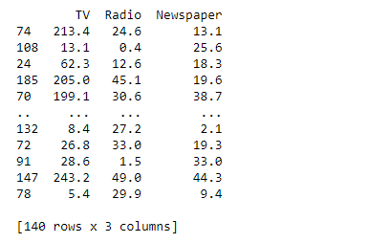

from sklearn.linear_model import LinearRegression

regressor = LinearRegression()

regressor.fit(X_train, y_train)



print(regressor.intercept_)



print(regressor.coef_)



y_pred = regressor.predict(X_test)

for(i,j) in zip(y_test,y_pred):

if i!=j:

print("Actual value :",i,"Predicted value :",j)

print("Number of mislabeled points from test data set :", (y_test != y_pred).sum())

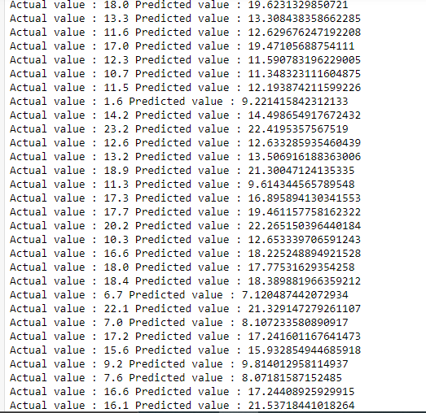

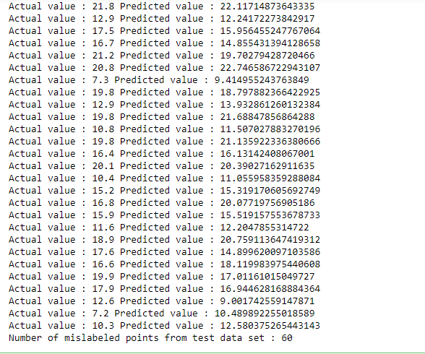

from sklearn import metrics

print("Mean Absolute error :", metrics.mean_absolute_error(y_test,y_pred))

print("Mean Squared error :", metrics.mean_squared_error(y_test,y_pred))

print("Root Mean Squared error :", np.sqrt(metrics.mean_squared_error(y_test,y_pred)))

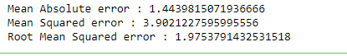

import matplotlib.pyplot as plt

c=X_test['TV'].count()

xax=np.arange(c)

print(xax)

X_axis = np.arange(len(xax))

plt.bar(X_axis-0.2, y_test, 0.6, label='Actual')

plt.bar(X_axis+0.2, y_pred, 0.6, label='Predicted')

plt.xlabel("Sales")

plt.ylabel("Actual/Predicted")

plt.title("Sales prediction")

plt.legend()

plt.show()

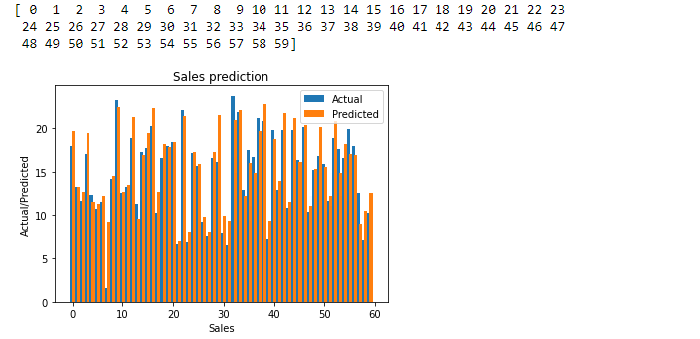

**Neural Networks**

**1.Create a neural network for the given ‘houseprice.csv’ to predict the whether price of the house is above or below median value or not.**

import tensorflow as tf

import keras

import pandas

import sklearn

import matplotlib

import pandas as pd

df=pd.read_csv('housepricedata.csv')

df

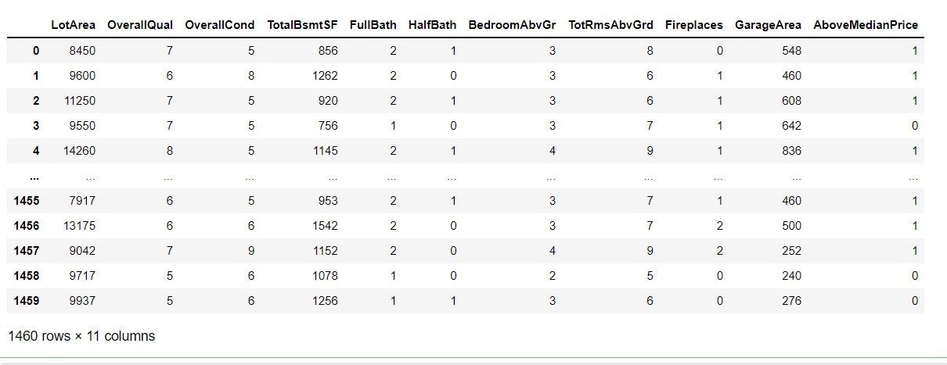

dataset = df.values

dataset

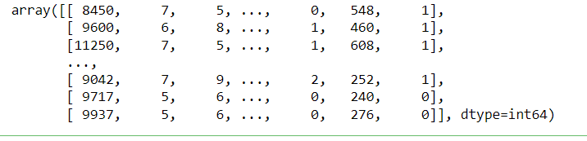

X = dataset[:,0:10]

Y = dataset[:,10]

from sklearn import preprocessing

min_max_scaler = preprocessing.MinMaxScaler()

X_scale = min_max_scaler.fit_transform(X)

X_scale

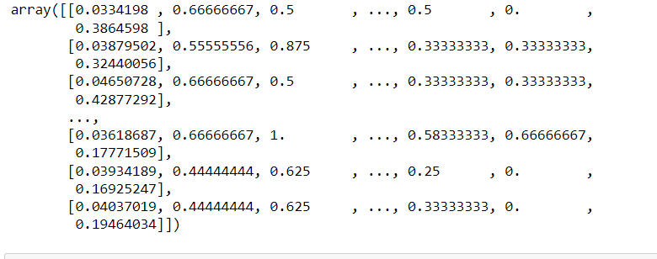

from sklearn.model_selection import train_test_split

X_train, X_val_and_test, Y_train, Y_val_and_test = train_test_split(X_scale, Y, test_size=0.3)

X_val, X_test, Y_val, Y_test = train_test_split(X_val_and_test, Y_val_and_test, test_size=0.5)

print(X_train.shape, X_val.shape, X_test.shape, Y_train.shape, Y_val.shape, Y_test.shape)



from keras.models import Sequential

from keras.layers import Dense

model = Sequential([

Dense(32, activation='relu', input_shape=(10,)),

Dense(32, activation='relu'),

Dense(1, activation='sigmoid'),

])

model.compile(optimizer='sgd',

loss='binary_crossentropy',

metrics=['accuracy'])

hist = model.fit(X_train, Y_train,

batch_size=32, epochs=100,

validation_data=(X_val, Y_val))

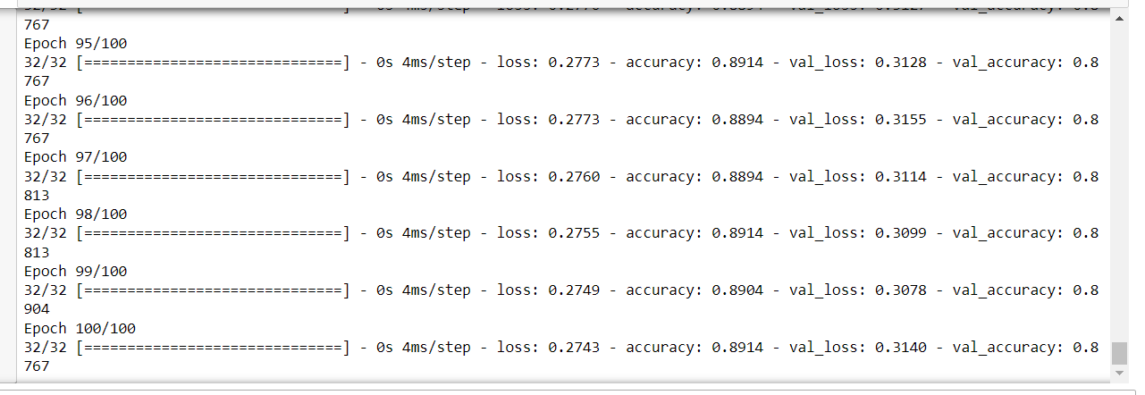

model.evaluate(X_test, Y_test)[1]

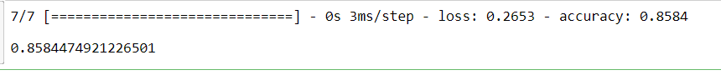

import matplotlib.pyplot as plt

plt.plot(hist.history['loss'])

plt.plot(hist.history['val_loss'])

plt.title('Model loss')

plt.ylabel('Loss')

plt.xlabel('Epoch')

plt.legend(['Train', 'Val'], loc='upper right')

plt.show()

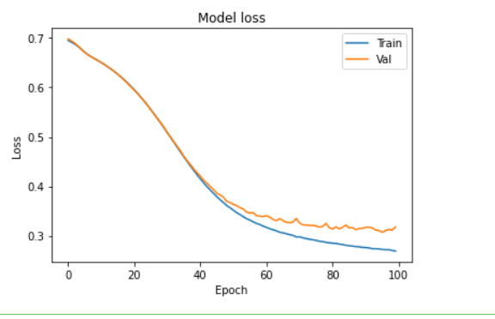

plt.plot(hist.history['accuracy'])

plt.plot(hist.history['val_accuracy'])

plt.title('Model accuracy')

plt.ylabel('Accuracy')

plt.xlabel('Epoch')

plt.legend(['Train', 'Val'], loc='lower right')

plt.show()

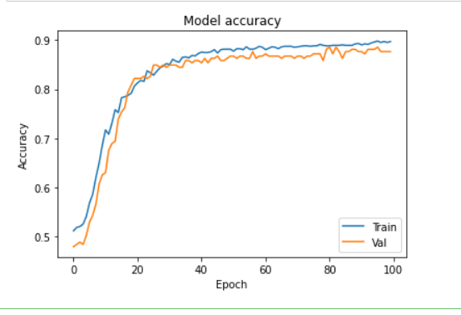

model_2 = Sequential([

Dense(1000, activation='relu', input_shape=(10,)),

Dense(1000, activation='relu'),

Dense(1000, activation='relu'),

Dense(1000, activation='relu'),

Dense(1, activation='sigmoid'),

])

model_2.compile(optimizer='adam',

loss='binary_crossentropy',

metrics=['accuracy'])

hist_2 = model_2.fit(X_train, Y_train,

batch_size=32, epochs=100,

validation_data=(X_val, Y_val))

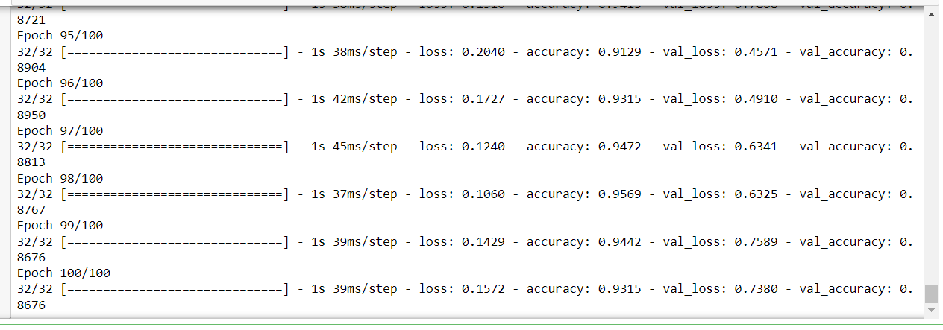

plt.plot(hist_2.history['loss'])

plt.plot(hist_2.history['val_loss'])

plt.title('Model loss')

plt.ylabel('Loss')

plt.xlabel('Epoch')

plt.legend(['Train', 'Val'], loc='upper right')

plt.show()

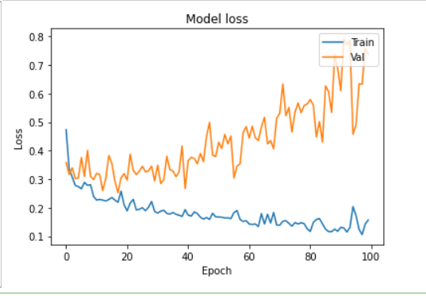

plt.plot(hist_2.history['accuracy'])

plt.plot(hist_2.history['val_accuracy'])

plt.title('Model accuracy')

plt.ylabel('Accuracy')

plt.xlabel('Epoch')

plt.legend(['Train', 'Val'], loc='lower right')

plt.show()

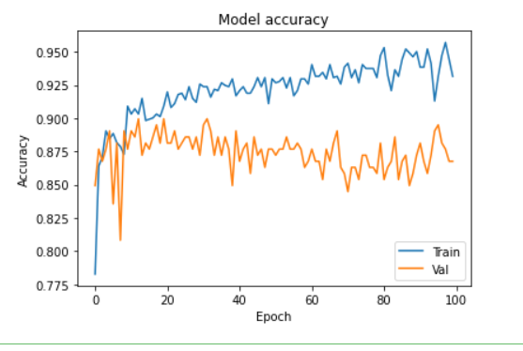

from keras.layers import Dropout

from keras import regularizers

model_3 = Sequential([

Dense(1000, activation='relu', kernel_regularizer=regularizers.l2(0.01), input_shape=(10,)),

Dropout(0.3),

Dense(1000, activation='relu', kernel_regularizer=regularizers.l2(0.01)),

Dropout(0.3),

Dense(1000, activation='relu', kernel_regularizer=regularizers.l2(0.01)),

Dropout(0.3),

Dense(1000, activation='relu', kernel_regularizer=regularizers.l2(0.01)),

Dropout(0.3),

Dense(1, activation='sigmoid', kernel_regularizer=regularizers.l2(0.01)),

])

model_3.compile(optimizer='adam',

loss='binary_crossentropy',

metrics=['accuracy'])

hist_3 = model_3.fit(X_train, Y_train,

batch_size=32, epochs=100,

validation_data=(X_val, Y_val))

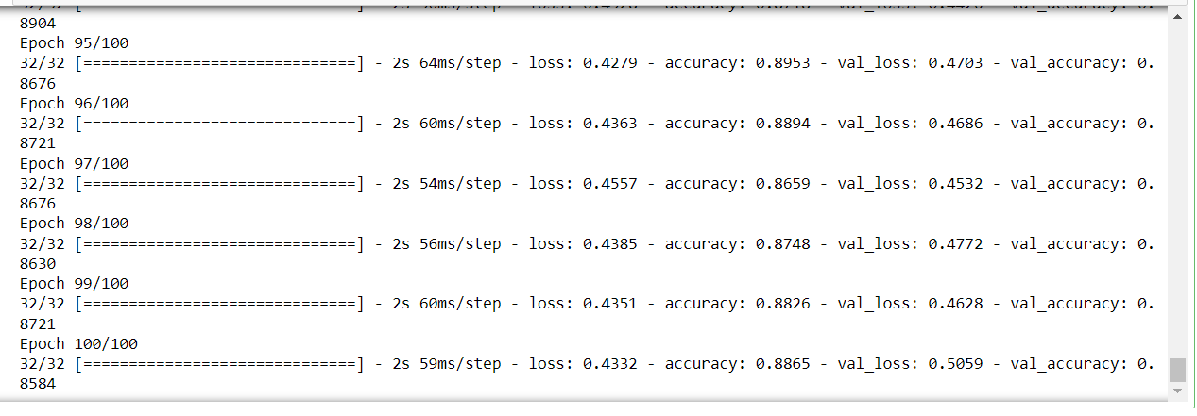

plt.plot(hist_3.history['loss'])

plt.plot(hist_3.history['val_loss'])

plt.title('Model loss')

plt.ylabel('Loss')

plt.xlabel('Epoch')

plt.legend(['Train', 'Val'], loc='upper right')

plt.ylim(top=1.2, bottom=0)

plt.show()

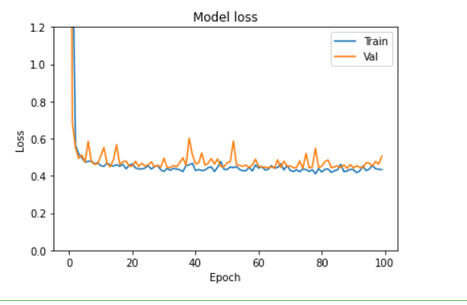

plt.plot(hist_3.history['accuracy'])

plt.plot(hist_3.history['val_accuracy'])

plt.title('Model accuracy')

plt.ylabel('Accuracy')

plt.xlabel('Epoch')

plt.legend(['Train', 'Val'], loc='lower right')

plt.show()

